NAME: ASMA SALEEM
ROLL NO: 2024-CET-07
CLASS: BS CET
SEMESTER: 04
SUBJECT: GRAPHICS DESIGNING
ASSIGMENT: 01
SUBMITTED TO: ENGR AHMED KHAWAJA

Q:- Create A4 poster on Cyber security Awareness

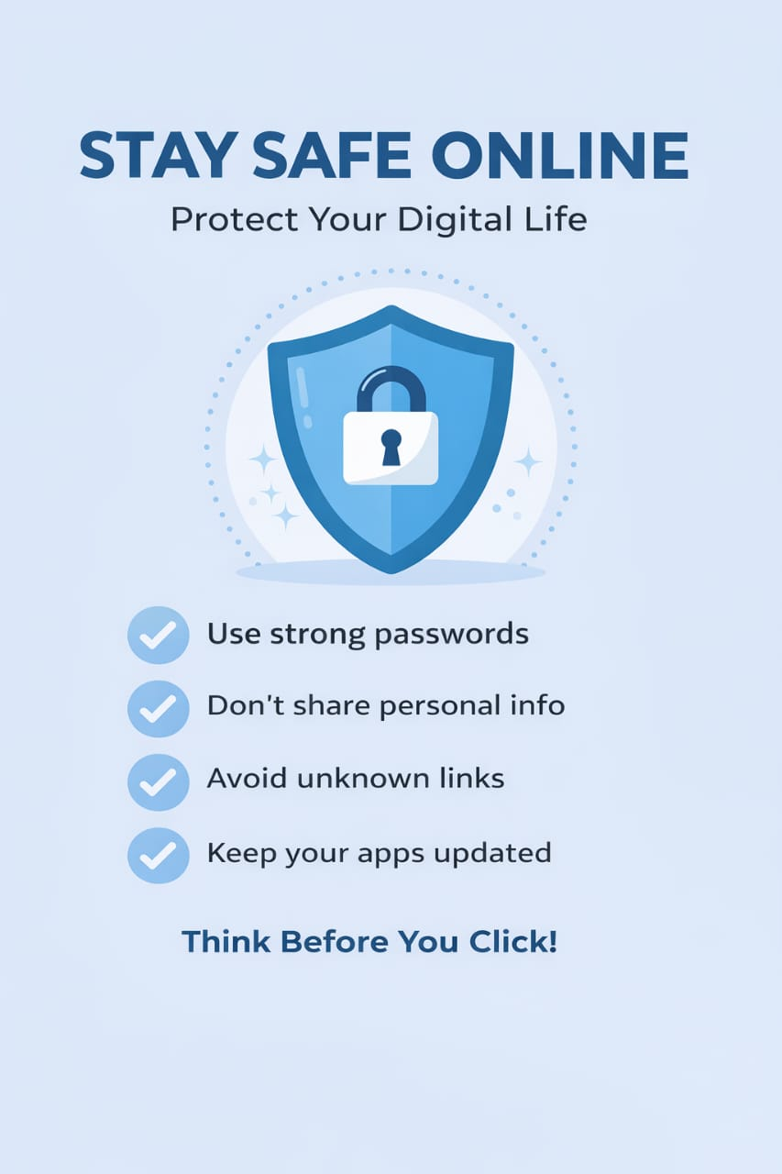
I designed this cyber security awareness poster using a simple and clean layout. I selected a light blue background with dark blue and black text to maintain a professional and calm look. Blue color represents trust security which matches the theme of cyber safety. I used only two fonts to keep the design neat a bold font for title to make it eye catching , and a simple readable font for the body text. The title is large and placed at the top so it grabs attention quickly. I added a central lock and shield icon to visually represent protection and security. The content is short and easy to understand, using bullets points for clarity. Overall the design is balanced , readable , and follows all the basics principles.

